


Azure Server Build Document

Index

Purpose: 1
Overview: 1
Steps: 2
QC / Validation: 2
Escalation Matrix: 2

Version Control:

Date | Author | Reviewer | Version | Updated Sections
08/01/2018 | HCL CloudOps | Rogers FTE | 1.0 | Initial Draft
08/08/2018 | HCL CloudOps | Rogers FTE | 1.1 | Updated sections

Purpose:

A step by step guide is to be used and followed when building a new Azure virtual machine from Golden Image

Overview:

Please follow the guidelines in this document when building a new virtual machine from a golden image.

Steps:

Step-by-Step guide to create an Azure Virtual Machine from Golden Image

Each subscription and region have an image created for Windows Server 2012 R2 and Redhat Linux Enterprise 7.3

- Open the Azure portal.
- In the left menu, select All resources. You can sort the resources by Type to easily find your images.
- Select the image you want to use from the list. The image Overview page opens.
- Click + Create VM from the menu.

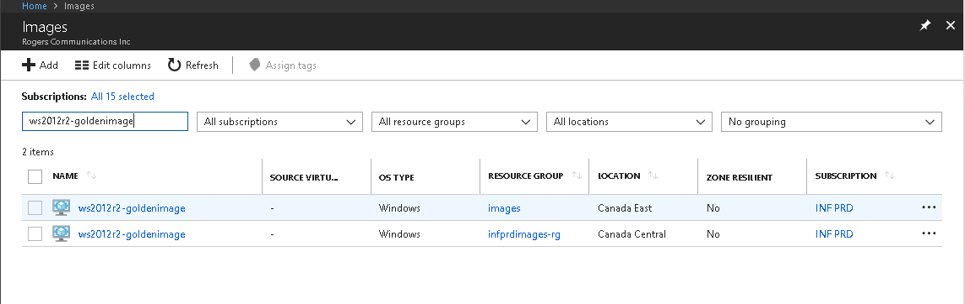

Note: Select an image from subscription and region where you want to provision VM in that subscription.

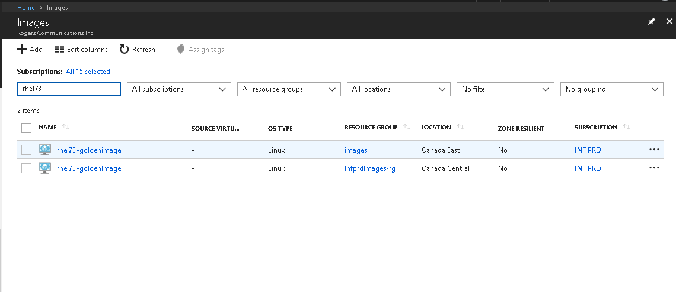
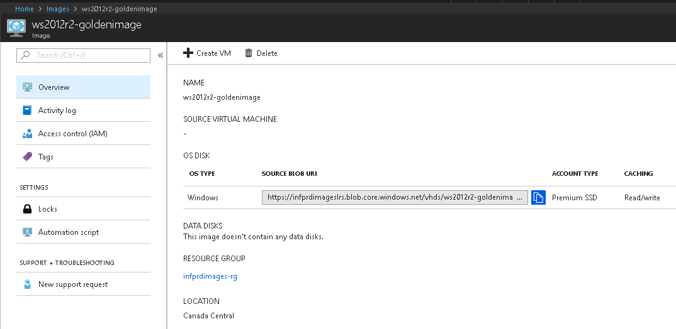

Click (Create VM) to proceed with creating the Azure Virtual Machine.

Next, the Create Virtual Machine blade should open and then extend the first blade to configure basic settings. You will now need to provide the below important details:

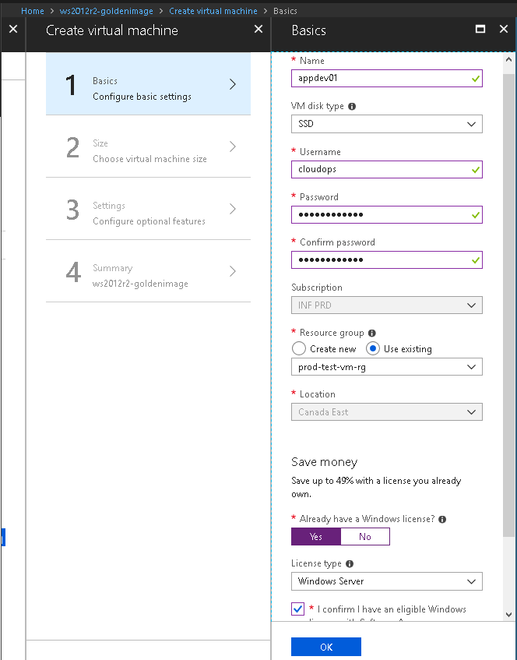

- Name: The name of VM. Please see naming convention chart before you give any name
- VM disk type: Choose SSD disk type
- User Name: The administrative username.
- Password: The password for the administrative user.
- Subscription: Select the subscription that is required for VM
- Resource Group: Create or select a logical container for Azure resources (to help manage resources that are often deployed together).
- Location: The Azure region where the VM should be placed.
- Windows License: Select “Yes” and license type is “Windows Server” since we have brought our own license in custom image.

After selecting the VM size, move to next section where you will set up features related to storage, networking, monitoring, and availability.

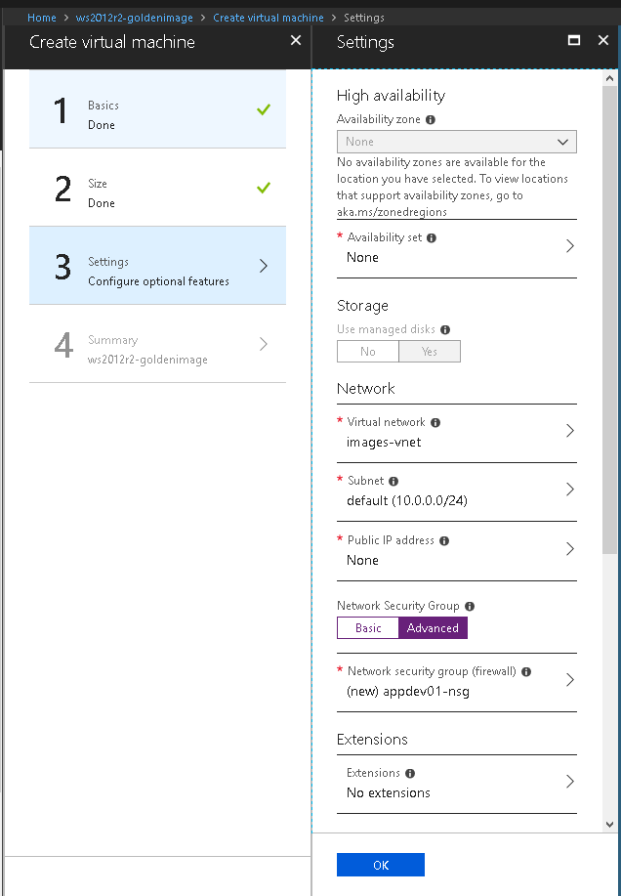

- Storage: The image is created on managed disk. By default managed disk would be selected.
- Virtual Network: Either select an existing VNET or consult with Infra team for new VNET if required.
- Subnet: Select the subnet (range of IP address from the VNET) in which to place the VM.
- Public IP Address: Select None to not have a publicly accessible IP address for the VM.
- Network Security Group: Select the existing NSG if newly required consult with Infra CloudOps team
- Boot Diagnostics: Enable boot diagnostics, this allows you to see the console output and supports screenshots for the Azure VMs.
- Guest OS Diagnostics: Choose to enable Guest OS diagnostic metrics for the VM. This can be used to create alerts and stay informed on the applications.
- Diagnostics Storage Account: Select either an existing Azure Storage account or create a new one to which diagnostic metrics are written.

Click OK to proceed to the final section.
Once some basic platform validation is complete, you will see a summary of the VM to be created. Select the Create button to start the deployment process.

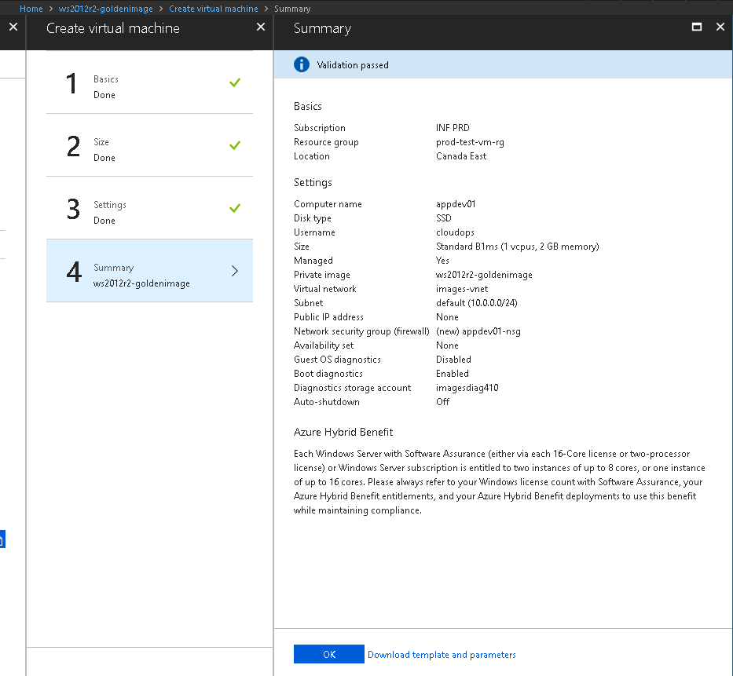

It may take several minutes before the VM is fully provisioned and ready for use. You will be able to monitor the status in the notification panel.

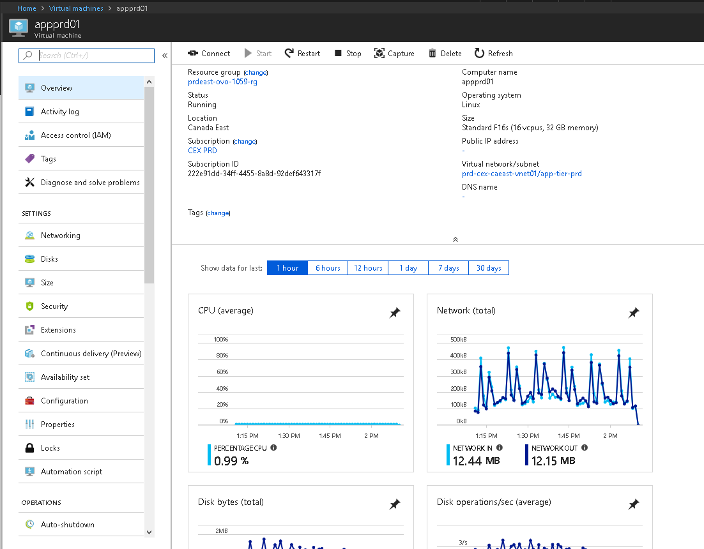

Once the VM is provisioned now it’s a time to set custom dns entries and join it to domain.

In the left menu click on “Networking”
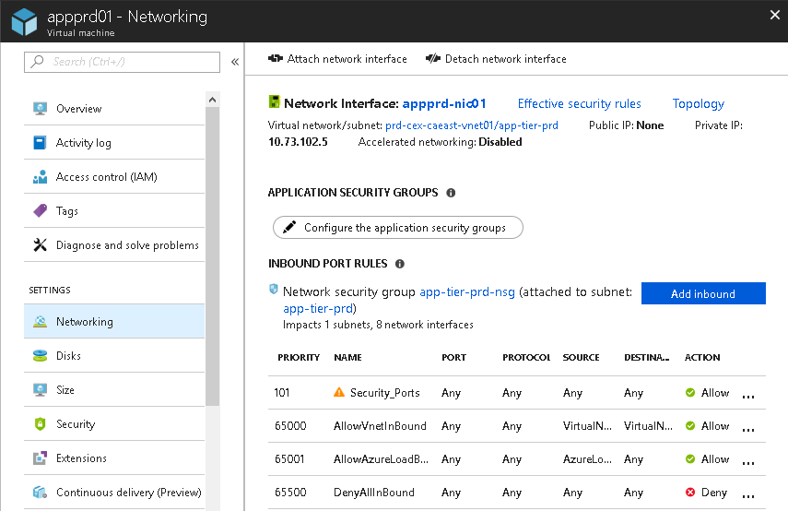

Click on “Network Interface: appprd-nic01 and then click on DNS Servers

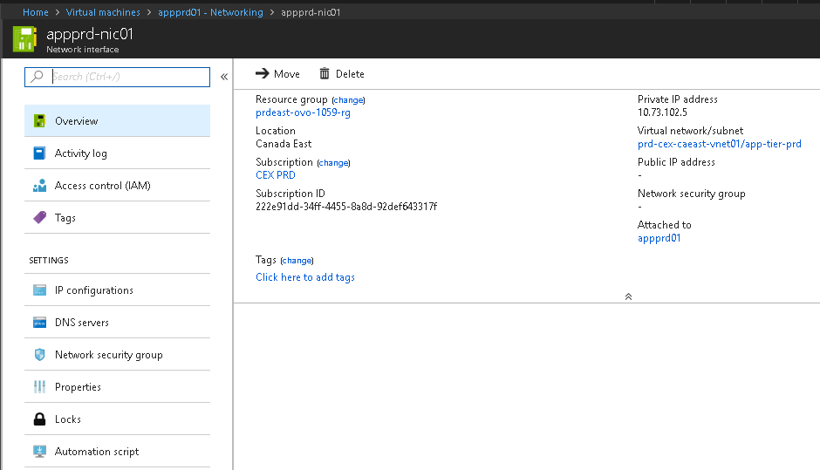
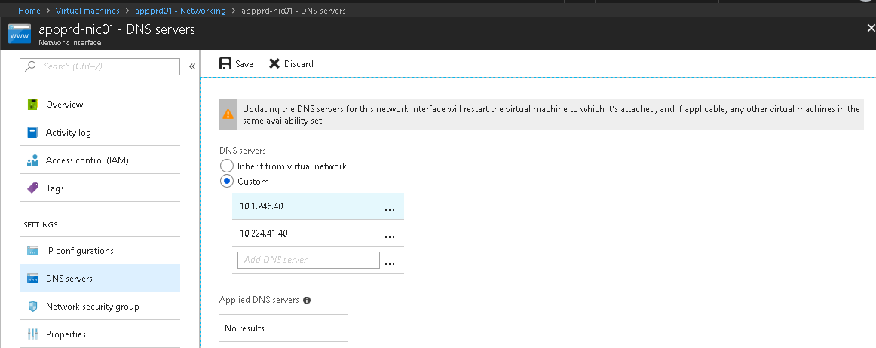

After you set the custom dns entries make sure you reboot the server, so changes will take effect.

Join VM to the domain
Right-click Start button and Select System.

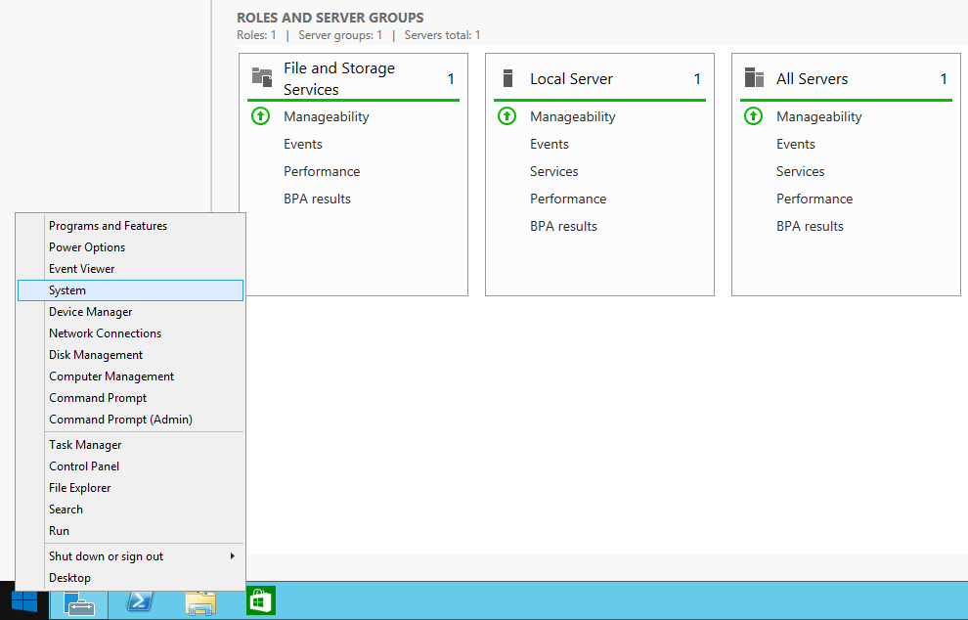
Click Change settings, a pop-up window “System Properties” will open
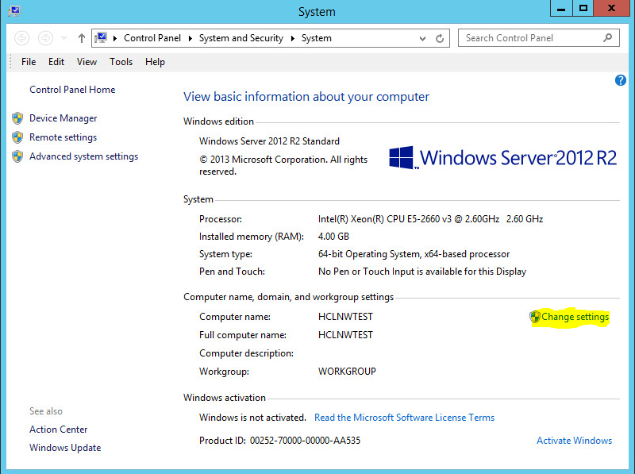

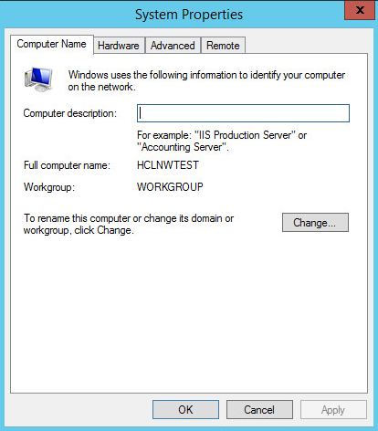

Click “Change” in the System Properties -> Compute Name
In the Compute Name/Domain Changes - > Member of , Select “Domain” and type “rci.rogers.ca”
Click ok,
Enter the credentials which has rights to join the server to domain in “Windows Security” pop-up window and click ok
Server will be joined to domain and Welcome message will pop-up.
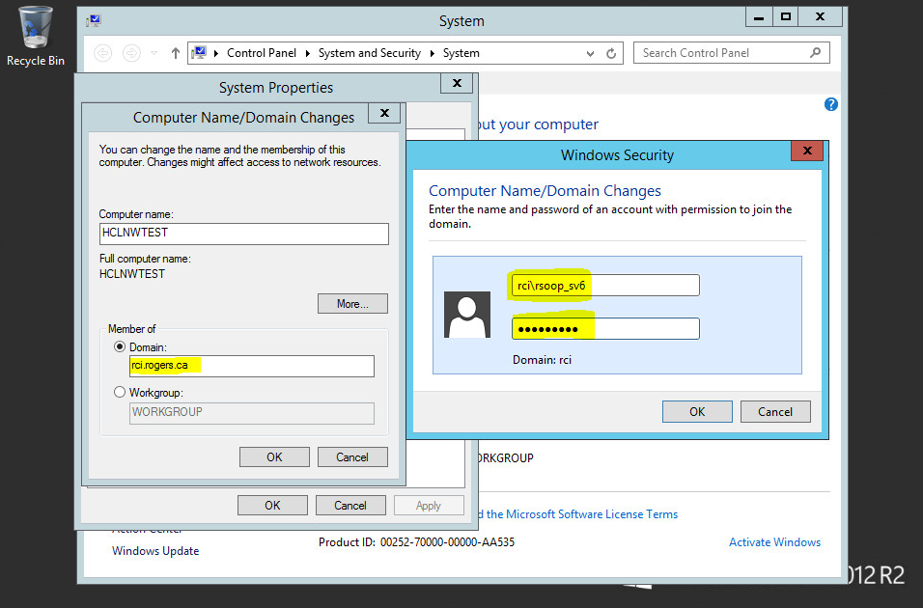

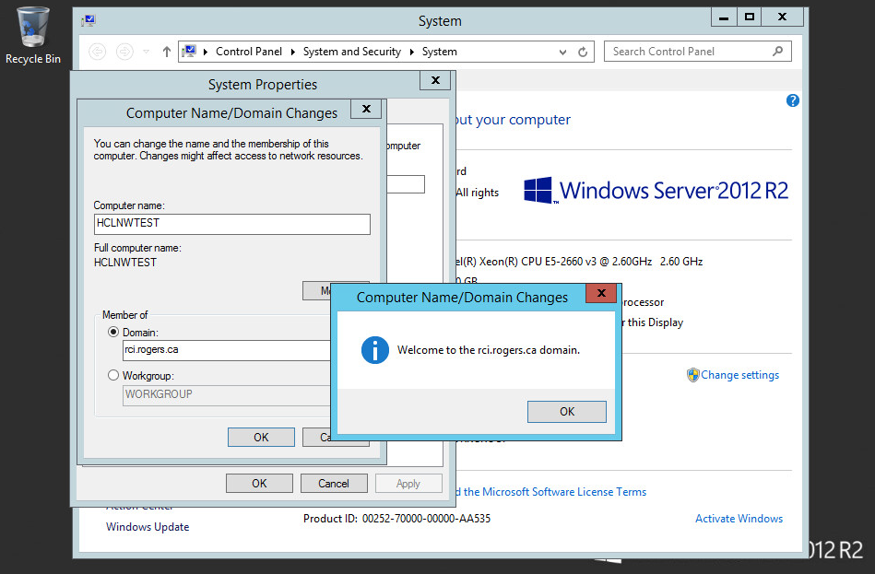

Hit okay and reboot the server for the changes to take place. Move the computer account to the proper OU ( application /DB/..). Contact the team lead if any special group policies are required.

Virtual Machine Tags:

Make sure you apply the tags on the VM. Tags information can be taken from the

E.g: appID:000, appsn:oas, env:dev

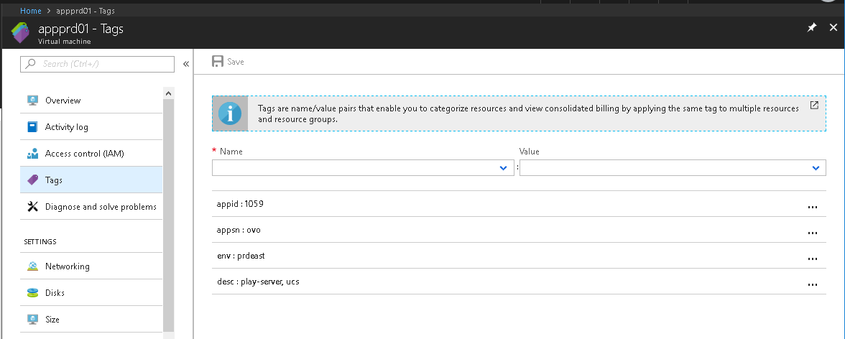

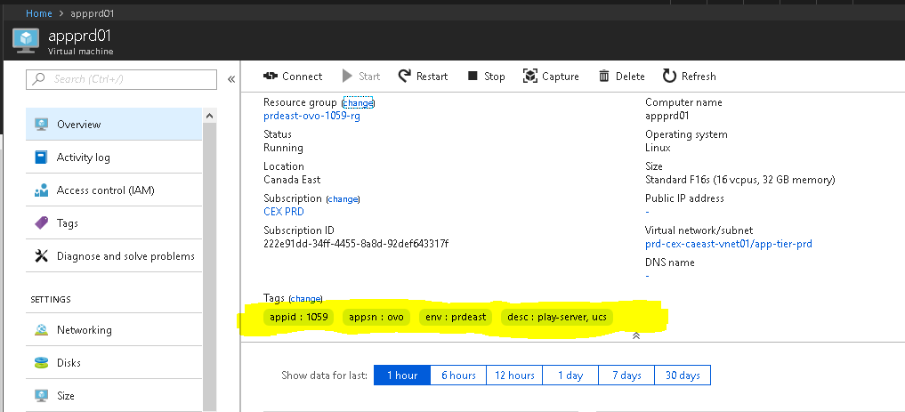

Azure OMG agent:

Installing the agent on an Azure VM is even easier than on-prem machines - through the Azure portal, open Log Analytics and select the workspace you want to keep the logs. In the Table of Contents you can find Virtual Machines (under "Workspace Data Sources"). This gives you a list of all your VMs, both Linux and Windows, and you can simply click the "connect" button after selecting a VM to connect.

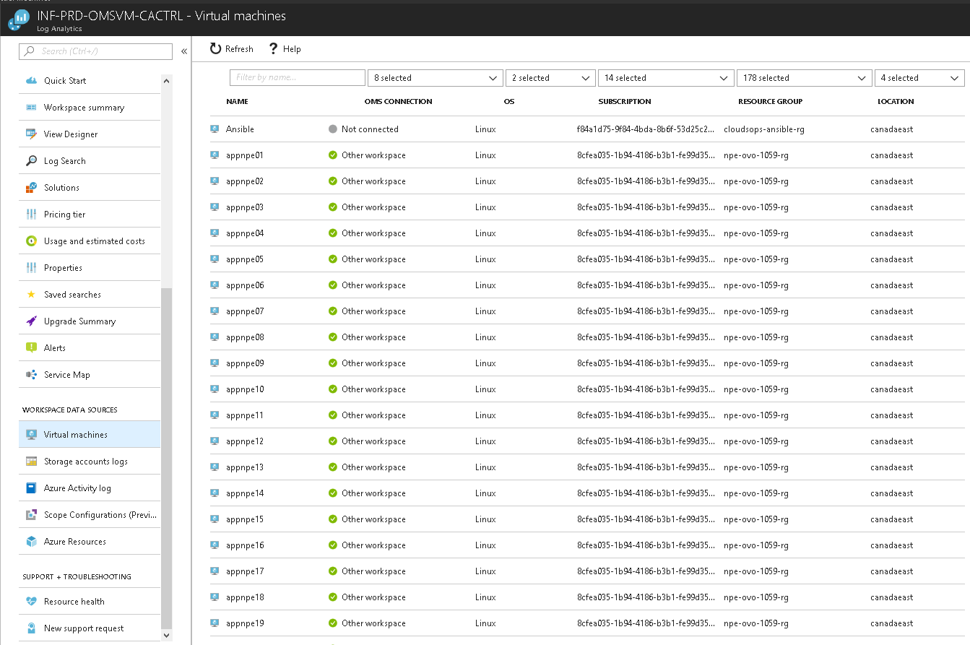

Note: If OMS agent is already installed please ensure OMS agent is running, reporting and pointed to the right OMS portal.

Enable VM Backup:
To enable backup for virtual machine, we only need to do the following:

Find and click on the desired VM
Select “Backup” on the Virtual Machine menu
Select the existing recovery services vault.
Select the existing backup policy
Click Enable Backup on the VM

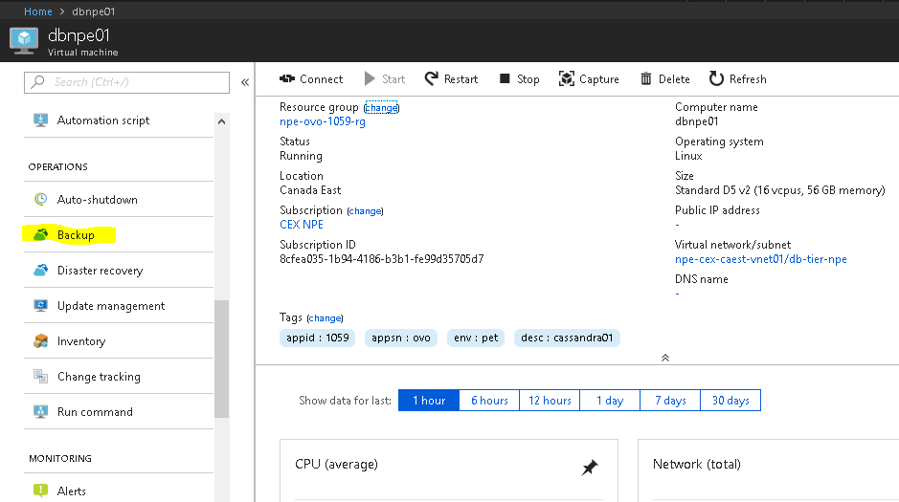

Select the existing recovery services vault and make sure that’s the right RSV if you don’t know then consult with Infra Cloud Ops team.
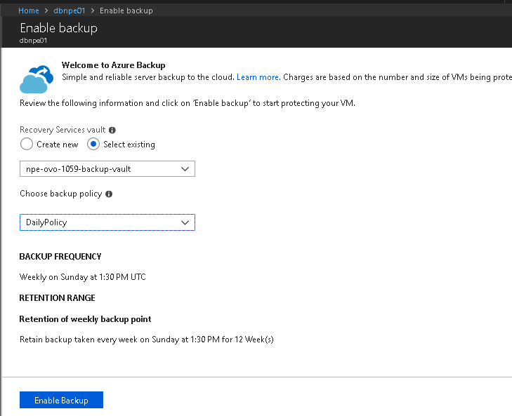

Naming Convention:

Resource | Name | Example
OS Disk | Vmname-os.vhd | APPdev-os.vhd
Data Disk | Vmname-data<index>.vhd | APPdev-data0.vhd, APPdev-data1
Network Interface | Vmname-nic<index> | APPdev-nic0
VM Name | <serverpurpose><environment><index> | appnpe01
Storage account name | <env><appshortname>st<number> | prdoasst01
Storage account name (disks) | <vmname>st<number> | vmnamest01
ScaleSet | <environment><function><osType><6-digit running number>”ss” | prdapw000123s

Resource Group | Naming Convention | Example
Resource Group | <env>-<appshortname>-<appid>-<tier>-rg | PRD-OAS-0084-web-rg
Key Vault | Appname<environment name>-kv-rg | Appnamedev-kv-rg
Network | Appname<environment name>-network-rg | Appnamedev-network-rg
Application | Appname<environmentname>-application-rg | Appnamedev-Application-rg

Azure Server Build Checklist:

Please follow the guidelines in this document when building a new virtual machine from golden image or deploying a new VM from Azure marketplace.

For every step that is completed for the new VM, please tick the box in the last column. Once done, please fill out your information and have your manager or supervisor sign the document.

New VM provision checklist
Item No. | Description of Task | Done
1 | Deploy a virtual machine from a Golden Image in portal Azure Images
2 | VM will be named according to this naming convention: <serverpurpose><environment><index> e.g: appprod01
3 | VM disk type & storage type must be SSD
4 | Select existing resource group if new RG required please consult with Infra Cloud Ops team
5 | Make sure you select “Already have a Windows license” option “Yes” and License type “Windows Server”
6 | Assign the existing Virtual Network “vNet” and Subnet that is required for the VM
7 | Do not assign any public IP Address unless it is requested
8 | Select an appropriate existing Network Security Group “Firewall” if not consult with Infra Cloud Ops team
9 | Once the VM is provisioned apply all missing Windows Updates and Service Packs
10 | Configure a custom DNS entries on VM, Primary DNS:10.224.41.40 | 10.1.246.40
11 | Join a VM to the domain and put it in the right OU it belongs to.
12 | Turn on the disk encryption on the VM
13 | Enable backup on the VM
14 | Make sure you apply the tags on the VM. Example: appID:000, appsn:oas, env:dev
15 | Turn off Internet Explorer Enhanced Security Configuration for Administrators
16 | Ensure you save the username and password in KeePass for the VM
17 | Install OMS agent if not already installed
18 | Get scan the VM by security team and make sure it passed the compliance report if not please harden and remediate all the vulnerabilities.

Machine FQDN
Type (Physical/Virtual)
Engineer
Date Completed
Requester
Manager’s Signature / Initials

QC / Validation:

Escalation Matrix:

